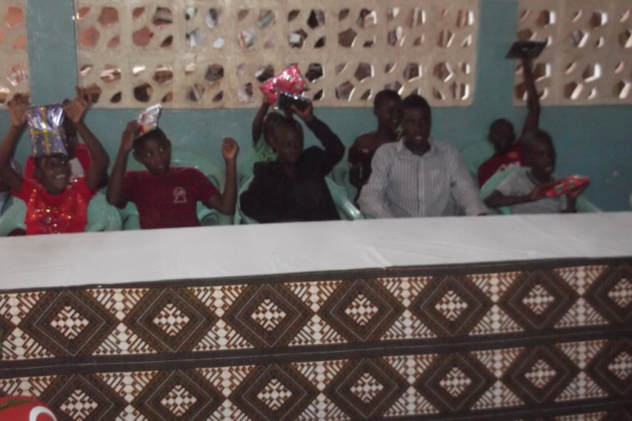Amani Children with their Christmas gifts.
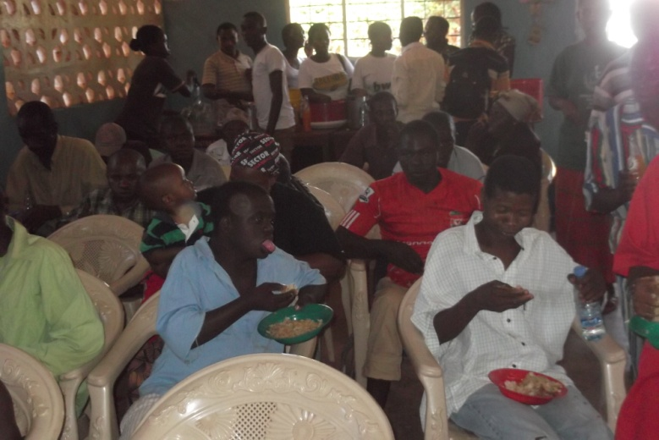
Children and elders enjoy a great Lunch during the Party.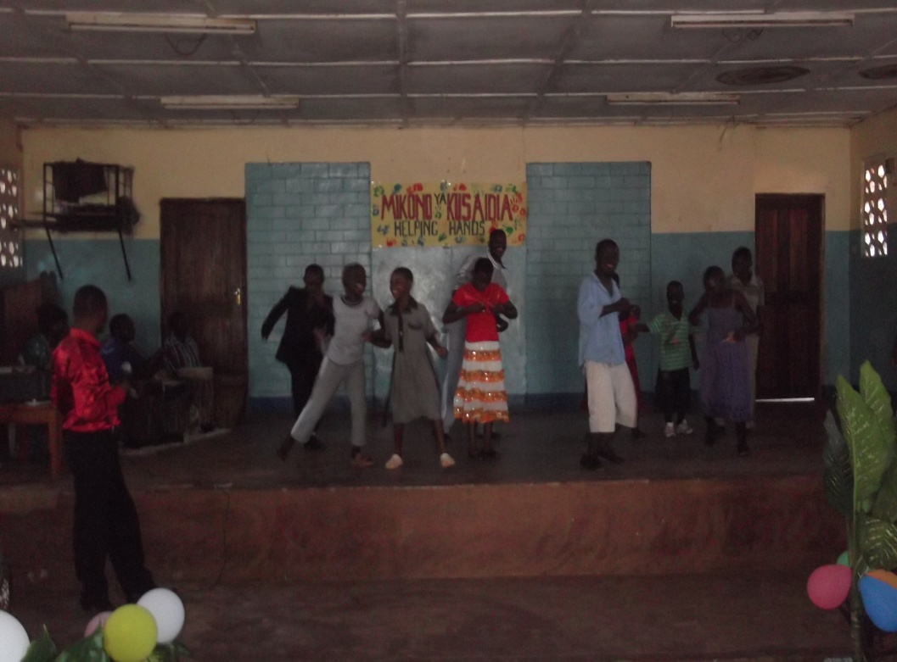
Amani and Mihayo Children enjoy the Music from the Amani awareness team.

